**Client-side scripting with JAVA SCRIPT (JS):**

1. Write a HTML program to enter two numbers in a form and validate that none of the two values should be set empty.

<html>

<head>

<title>Validation</title>

</head><body>

<h1>Validation of two numbers</h1>

<div>

<form id="Myform" onsubmit="return validate()">

<label for="Num1">Enter the first number</label>

<input type="Number" id="num1" name="num1"> <br> <br>

<label for="Num2">Enter the second number</label>

<input type="number" id="num2" name="num2"> <br> <br>

<input type="submit" value="submit">

</form>

</div>

<script>

function validate()

{

var a=document.forms["Myform"]["num1"].value;

var b=document.forms["Myform"]["num2"].value;

if(a == "")

{

alert("WRONG VALUE ENTERED");

return false;

}

if(b == "")

{

alert("WRONG VALUE ENTERED");

return false;

}}

</script>

</body>

</html>

Output:

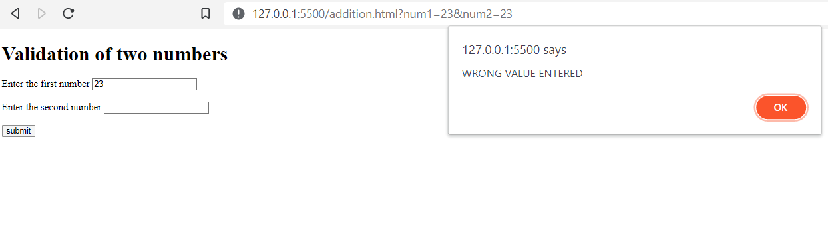

1. Write a HTML program to create a form including username, email and password and checkbox for selecting courses for registration.

Validate that username and email should not be empty, and password should be at least 8 characters long.

<html>

<head>

<title>Form validation</title>

</head><body>

<h1>FREE REGISTRATION</h1>

<div id="C050"><p>

<form id="Myform" onsubmit="return validate()">

<label for="Name">Full Name</label> <br> <br>

<input type="text" id="name" name="name"> <br><br>

<label for="Email">E-mail address</label> <br> <br>

<input type="Email" id="email" name="email"> <br><br>

<label for="password">Password</label> <br> <br>

<input type="password" id="password" name="password"> <br><br>

Select your prefered course/s: <br> <br>

<input type="checkbox" name="JSnode" value="JSnode" >

<label for="JSnode">JSnode</label> <br> <br>

<input type="checkbox" name="Python" value="Python" >

<label for="Python">Python</label> <br> <br>

<input type="checkbox" name="Mongo" value="Mongo" >

<label for="Mongo">Mongo</label> <br> <br>

<input type="submit" value="submit">

</form></p></div>

<script>

function validate()

{

var a=document.forms["Myform"]["name"].value;

var b=document.forms["Myform"]["email"].value;

var c=document.forms["Myform"]["password"].value;

if(a=="")

{

alert("Empty names not allowed");

return false;

}

if(b=="")

{

alert("Empty Emails not allowed.");

return false;

}

if(c.length<8){

alert("Invalid password !! Password length must be atleast 8 characters.");

return false;

}}

</script></body></html>

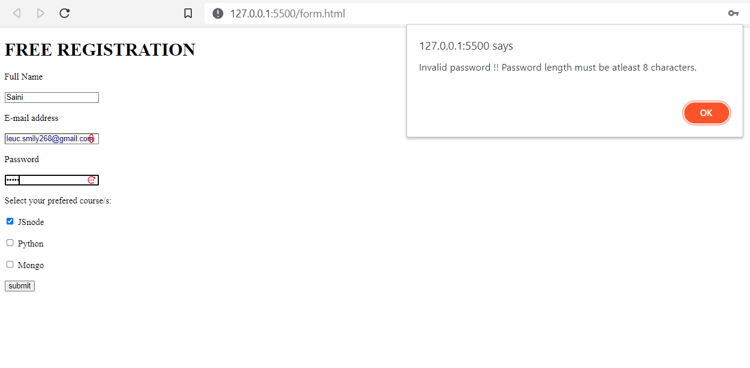

1. Write an HTML program to print out a list of subjects using var function in Javascript.

<html>

<head>

<title>Displaying an array</title>

</head>

<body>

<h1>Displaying an array</h1>

<div id="demo"></div>

<script type="text/javascript">

var array=['CSIT','BCA','BIT','BIM'];

document.getElementById("demo").innerHTML=array;

</script></body>

</html>

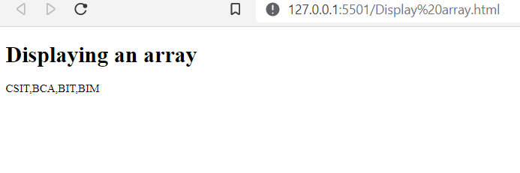

**Event handling in JS:**<html lang="en">

<head>

<title>Event Handling</title>

</head>

<body>

<h1>Google</h1>

<!-- Types of Event Handlers used in javascript -->

<p>

<!-- Onclick -->

<a href="https://www.google.com" id="google" onclick="return yesorno()"><div style="font-size: 50px;">Google</div></a>

<br><br>

<!-- onmouseover -->

<a href="https://www.google.com" onmouseover="alert('Your battery is draining faster.')"><input type="button" value="Search"></a>

<br><br>

<!-- Onload -->

<img src="C.jpeg" alt="Dogs and cats.jpeg" width="350px" onload="alert('VIRUS ALERT')"> <br><br>

<!-- Onmouseout -->

<a href="https://www.github.com" onmouseout="alert('VIRUS ALERT')">Github</a>

<br><br>

<!-- onunload -->

<a href="https://www.youtube.com" style="font-size: large;" onselect="alert('Youtube is a online social media platform')"> Youtube</a>

</p>

<script>

function yesorno()

{

let a= confirm("Are you sure you want to leave this website?");

if (a==true){

return true;}

else

{

return false;}

}

</script></body></html>

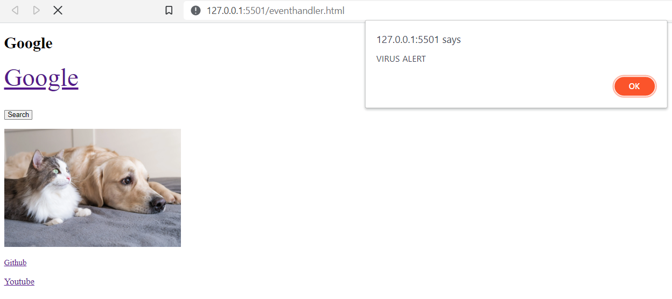

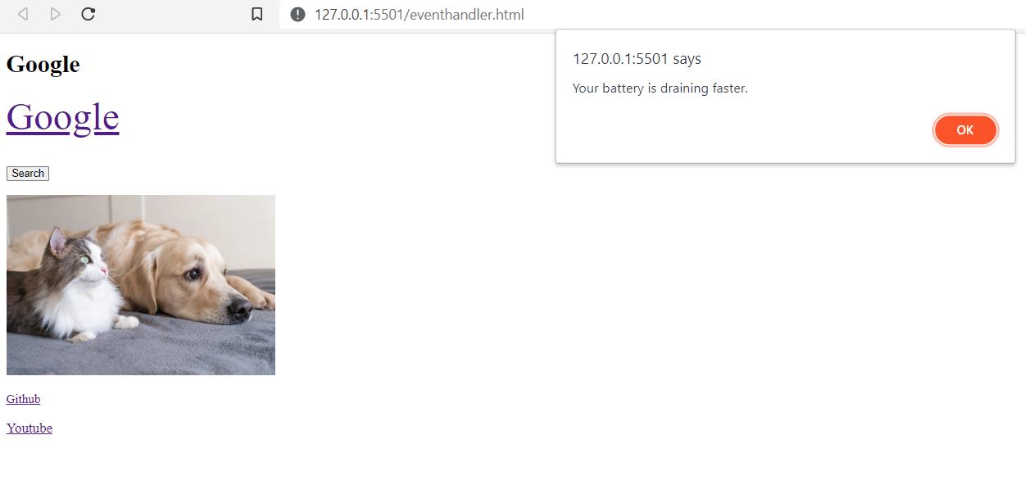

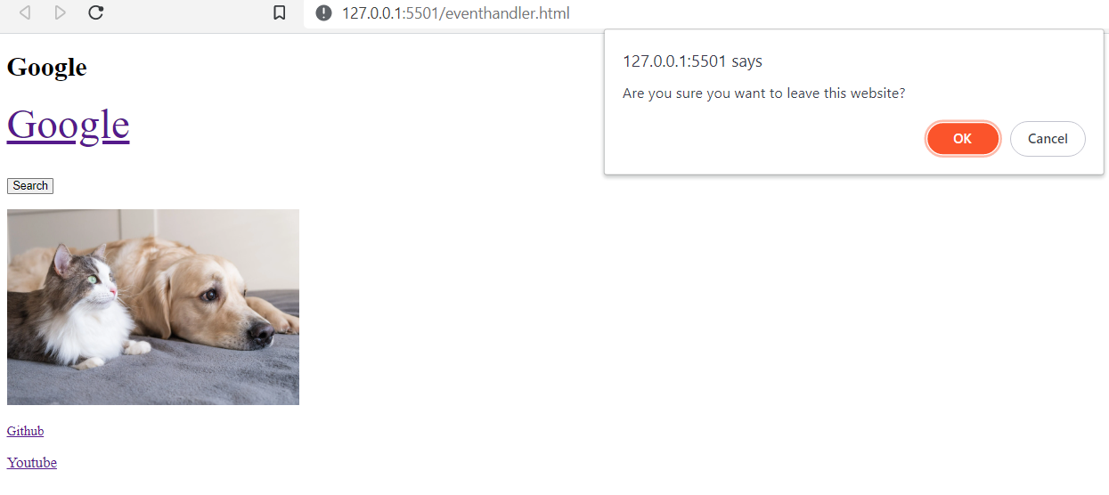

1. Write an HTML program to enter a username, contact number and select gender in a form for which the username should not be empty, contact should not be empty and should be Number, and the gender should be specified(selected).

<html>

<head>

<title>Form Validation</title>

</head>

<body>

<h1>Registration</h1>

<p>

<form id="myform" onsubmit="return validate()">

Username: <input type="text" id="name"> <br> <br>

Number: <input type="text" id="number"> <br> <br>

Gender: <input type="radio" name="gender" id="Male">Male

<input type="radio" name="gender" id="Female">Female <br> <br>

<input type="submit" value="Submit">

</form></p>

<script type="text/Javascript">

function validate()

{

var name= document.forms["myform"]["name"].value;

var number= document.forms["myform"]["number"].value;

if (name=="")

{

alert("Enter name");

return false;

}

if (number=="")

{

alert("Enter the Number");

return false;

}

else if(isNaN(number))

{

alert("Enter a valid number");

}

// radio validation

var male=document.forms["myform"]["Male"].checked;

var female=document.forms["myform"]["Female"].checked;

if(male==false && female==false)

{

alert("Gender need to be specified");

return false;

}

}

</script></body></html>

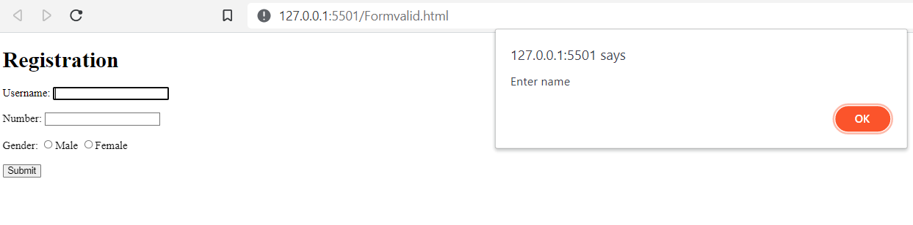

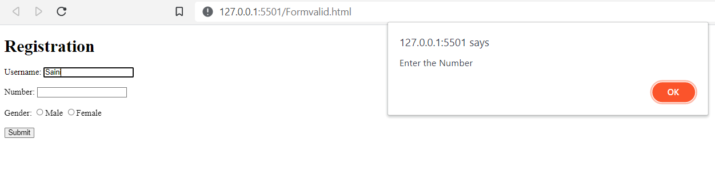

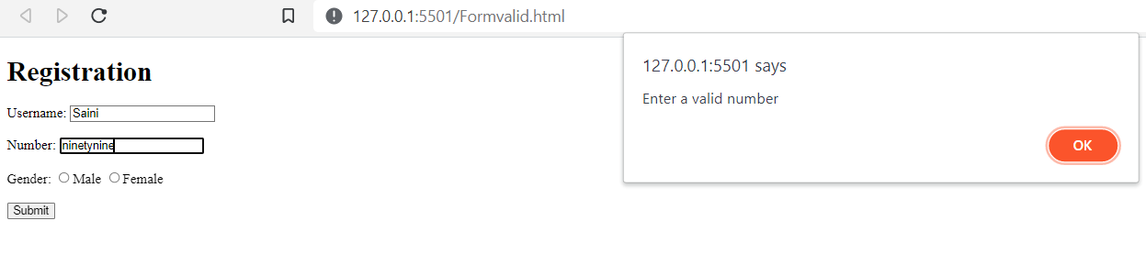

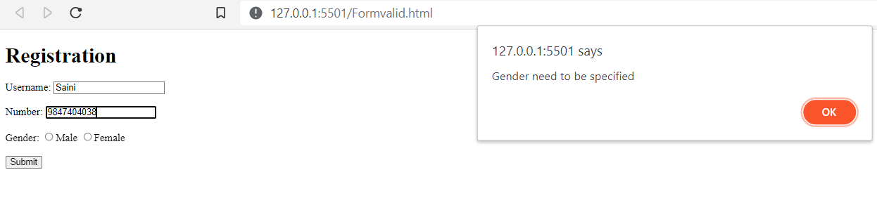

**Cookie Handing:**

<html lang="en">

<head>

<title>Cookie handling</title>

</head>

<body><p>

<h1>Cookie Handling</h1>

<div>

<form onsubmit="Setcookie()" name="myform">

<label for="name">Name: </label>

<input type="text" id="Name" name="Name"> <br> <br>

<input type="submit" value="Set Cookie">

<!-- <input type="button" value="Set Cookie" onclick="Setcookie()"> <br> <br> -->

<input type="button" value="Get Cookie" onclick="getcookie()"> <br> <br>

</form></div></p>

<script>

function Setcookie()

{

var a = document.forms["myform"]["Name"].value;

document.cookie = a;

}

function getcookie()

{

if(document.cookie.length!=0)

{

alert(document.cookie);

}

else{

alert("No Cookie available");

}

}

</script></body></html>

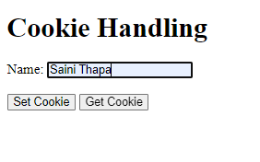

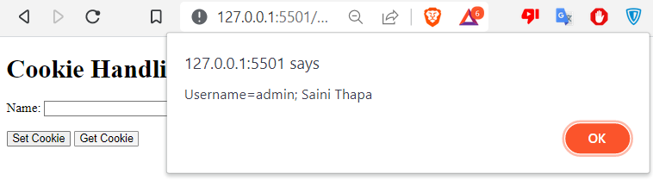

1. Write an HTML program describing the use of JQuery selectors.

<html lang="en">

<head>

<title>JQuery</title>

<script src="https://code.jquery.com/jquery-3.6.0.min.js"></script>

</head>

<body>

<h1>Jquery selectors</h1>

<!-- Element selector -->

<p>This is the JQuery element selector</p>

<!-- ID selector -->

<div id="myDiv">Hello, World!</div> <br>

<!-- class selector -->

<button class="myButton">Click me</button>

<script>

//change the text of the p element

$('p').text('This is the changed text in the element p');

//change the text of the element with "myDiv" id

$('#myDiv').text('Hello, JQuery!');

//add a click event handler to the element with "myButton" class

$('.myButton').click(function(){

alert('Button Clicked!');

});

</script>

</body>

</html>

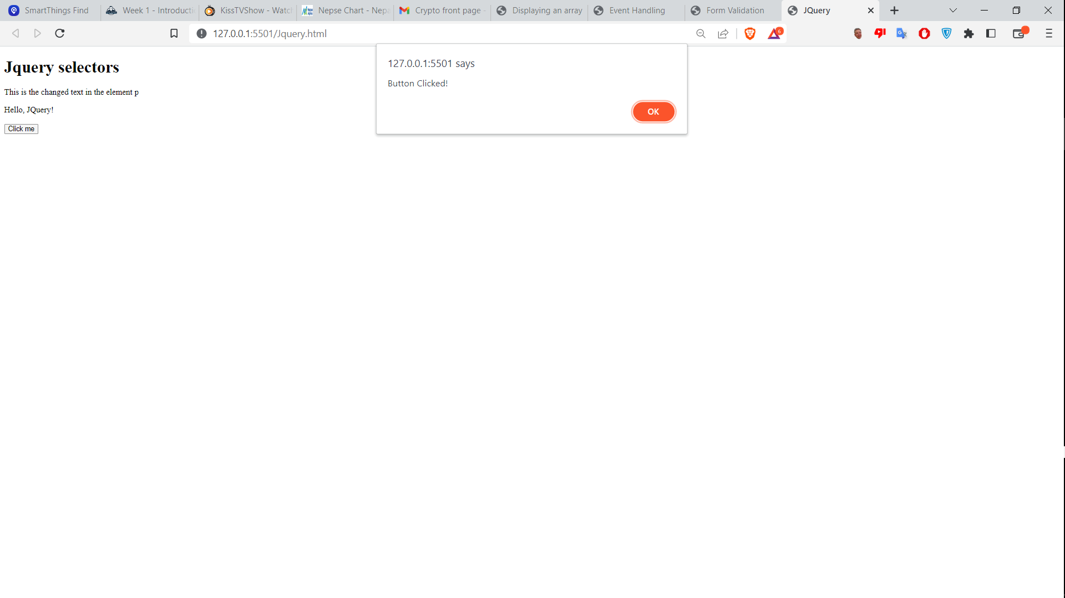

1. Write a program to create object using JSON string.

<html>

<head>

<title>JSON Parsing</title>

</head>

<body>

<h2>Create Object from JSON String</h2>

<p id="demo"></p>

<script type="text/javascript">

var txt='{"name":"John","Age":"30","City":"New York"}';

var obj=JSON.parse(txt);

document.getElementById("demo").innerHTML = obj.name + ", " + obj.Age + " ( " + obj.City + " )";

</script>

</body>

</html>

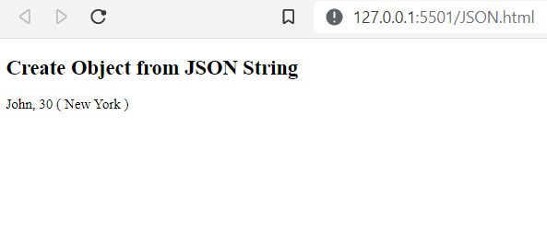

**JQuery effects:**

<html>

<head>

<title>JQuery Effects</title>

<script src="https://code.jquery.com/jquery-3.6.0.min.js"></script>

<style>

.box{

width: 200px;

height: 200px;

background-color: #f0f;}

</style></head>

<body>

<button id="toggleButton">Toggle Box</button> <br><br>

<div class="box">Lorem ipsum dolor sit amet consectetur adipisicing elit. Eveniet, perspiciatis fuga. Sequi dolore vitae, ab architecto asperiores vero alias possimus quod, modi animi illum error ipsa odio voluptates provident! Facilis.</div>

<p>Lorem, ipsum dolor.</p>

<script>

$('toggleButton').click(function(){

$('.box').fadeToggle(1000);

$('p').slideDown(1000);

});

</script>

</body>

</html>

